CS-004 Mold Sealing, Release & Surface Prep
Doc ID | CS-004
Title | Mold Sealing, Release & Surface Prep
Revision | E
Status | Draft, pending Lead signature
Effective date | 2026-10-10
Supersedes | Duratec spray sealing (retired); SN5 Mold Sealer Alternatives study (2025-10-19, overtaken)

Approvals
Role | Name | Date
Author | Simon Starbuck (drafted with Claude, SN6 Resources) | 2026-07-12
Reviewer | simon (reviewer agent) | 2026-10-10
Approver (Composites Lead)

Revision history
Rev | Date | Author | Description of change
A | 2026-07-12 | Claude | Initial issue, codifies the XCR system adopted spring 2026; TDS numbers verified against R1
B | 2026-07-28 | Claude | Language pass: fewer em dashes for rhythm variety, no content change.
C | 2026-08-03 | Claude | New §7.5 Identify, the last step after every wet operation: where the mold label goes, the 40 mm flange keep-out, the 220-grit scuff, and the reprint-on-reseal rule (CS-001 §7.4).
D | 2026-08-28 | Claude | Engineering pass (CS-000 Rev C conventions). Figure 1 draws the full release stack in section and puts the overcoat window on a timeline, because the window is the one number in this doc that expires while you watch. No rule changed.
E | 2026-10-10 | Claude (doc overhaul, requested by Simon Starbuck) | §6 hazards corrected to the XCR SDS, plus a shall: no XCR after a past skin reaction. §7.3 adds the 12 h FEB hold before release, jug temperature, the next-session recoat path and a should for mixed-grade molds; the overcoat time is now a fingernail check, not a deadline. App fields named in §7.4, §7.5 and §9, ending at Ready for layup. Scope points to CS-003 Appendix A; storage and IPA grade added; headings reworded for search. Title field matches the H1 (R-IDX-04). Eye PPE from the XCR SDS: safety glasses as a shall, EN 166 goggles as a should with goggles on the purchase list (Simon, 2026-10-10). IPA grade stated as a team rule. Round 6 fact-check: the 1 h wax out-gas wait before PVA added as §7.4 step 2 from the Formula Five and Partall guides (R-004-30), so §7.4 steps 2 to 4 become 3 to 5; the wax and PVA coat counts and the 800 grit denib marked as team values; the label patch is one rule, the 40 mm keep-out (R-001-30, Round 3 row); emphasis bold dropped; §6 notes the XCR SDS §11.1 respiratory-sensitiser warning; §7.3 step 4 plans two coats on 45 lb board (team rule), now that CS-003 lists that grade. Register R-004-01..14, R-004-30.

1. Purpose
Mold surface prep was our single most expensive recurring problem in SN5 (PP-01). Duratec was pricey, pooled in crevices and hid our scribe lines, needed high-grit sanding on soft board, and we sanded through it constantly; every incident cost a day-plus re-coat cycle. In spring 2026 we switched to XCR coating resin: paint it on, no sand-back, better finish, better geometric accuracy. This doc locks that decision in and gives one procedure from "machined mold" to "ready for layup", so the reasoning doesn't get lost and re-argued next year.

2. Scope
CNC-machined polyurethane tooling-board molds (30–60 lb/ft³, Coastal Enterprises stock) used for resin infusion or wet layup. Not covered: 3D-printed compression (forged CF) molds (CS-003 Appendix A) and hotwire foam male molds.

3. References
Ref | Document | Where
R1 | XCR Epoxy Coating Resin TDS | 03 Datasheets/EC-TDS-XCR-Epoxy-Coating-Resin.pdf
R2 | XCR SDS | 03 Datasheets/EC-SDS-XCR-Epoxy-Coating-Resin-Combined.pdf
R3 | Partall Film #10 (PVA) guide + SDS | 03 Datasheets/PARTALL-Film-10.pdf, SDS-PF10-5.5-en-NA-2025-01-28.pdf
R4 | Formula Five Mold Release Wax guide + SDS | 03 Datasheets/FORMULA-FIVE-Mold-Release-Wax.pdf, SDS-F5MRW-5.3-en-NA-2025-01-28.pdf
R5 | Formula Five Clean 'N Glaze guide + SDS | 03 Datasheets/FORMULA-FIVE-Clean-N-Glaze.pdf, SDS-CG-5.3-en-NA-2025-01-28.pdf
R6 | PP-01 RCA (Duratec history) | FEB-COMP-PP-001 §PP-01
R7 | SN4 Mold Manufacturing Problems and Solutions (cleanliness regimen) | SN5 Composites/Documentation/SN4 Mold Manufacturing Problems and Solutions.docx
R8 | Isopropyl alcohol SDSs, 91% and 70% (stand-ins for the team's bottles: hazards only, no numbers read from them) | 03 Datasheets/SDS-Isopropyl-Alcohol-91-Alliance.pdf, 03 Datasheets/SDS-Isopropyl-Alcohol-70-Fisher-A459.pdf

Why these products: XCR is a purpose-made brushable epoxy coating (R1) that cures to a hard surface without requiring sand-back. It fixes exactly the two Duratec failure modes (mandatory sanding on soft board; pooling that hides marks). The Rexco release system (R3–R5) is sponsor-supplied (~free) and wax + PVA film is the industry-standard belt-and-suspenders release for epoxy on epoxy-sealed molds.
XCR key numbers (from R1 unless the row says otherwise):
Property | Value
Mix ratio | 100 : 41 resin : hardener by weight (2 : 1 by volume; weight preferred)
Pot life (150 g mixed) | 8 min at 20 °C; 4 min at 30 °C
Overcoat time | about 2 h 50 at 20 °C, 1 h 30 at 30 °C: the first coat is usually firm but tacky by then. Check with a fingernail; the state decides, not the clock
If tack-free (overcoat time passed, or another day) | cure ≥9 h (20 °C), then key with 120-grit before recoating
Initial cure (handleable) | 8 h 30 at 20 °C; 4 h 30 at 30 °C; handleable at about 9 h at 20 °C
FEB hold before the release system (team hold, not R1) | 12 h after the last coat (CS-008 §5; app/resins.js, XCR row)
Full mechanical properties | ≥14 days at 20 °C (no post-cure oven available; plan mold use accordingly)
Application window | ambient 15–30 °C; ≥20 °C recommended and held through cure; both jugs inside 15–30 °C before mixing; avoid high humidity
Water exposure | none until ≥24 h after application
Storage | 20–25 °C, tightly sealed; 12-month shelf life. Where it lives: CS-011

4. Definitions
- Sealing: closing the open cells of machined tooling board so laminating resin cannot soak in and lock the part on.
- Release system: the sacrificial layers (wax, then PVA film) that let the cured part separate from the sealed mold.
- Etch / scribe lines: machined reference marks on the mold (part trim lines, datums). Preserving their visibility is a hard requirement of sealing.
- B-stage / firm-but-tacky: resin firm enough not to flow, soft enough to indent with a fingernail, slight surface tack: the correct state for overcoating (R1).

5. Equipment & Materials
Item | Spec / product | Source | Notes
Coating resin | XCR (resin + hardener), 100:41 by weight | Easy Composites | R1. Order ≥6 weeks ahead (UK customs, PP-02)
Digital scale | 1 g resolution or better | RFS | Ratio errors = soft spots
Mixing cups ×2 per batch | Graduated | Consumables box | Double-pot per R1 (transfer + remix)
Brushes | Disposable, solvent-safe | Consumables box | One per batch; do not clean/reuse
Compressed air | Shop air / duster | RFS | Step 7.1 [held for Simon: shop vacuum instead, REGISTER R-004-15]
Isopropyl alcohol + microfiber cloths | The 91% isopropyl bottle (team rule; the app records it as "Isopropyl alcohol 91%"), never the 70% rubbing alcohol | Chemicals box | Never acetone, never fibrous shop towels (R7). SDS: R8
Release wax | Formula Five Mold Release Wax | Rexco (sponsor) | R4
PVA release film | Partall Film #10 | Rexco (sponsor) | R3
Mold cleaner | Formula Five Clean 'N Glaze | Rexco (sponsor) | R5, for re-used molds

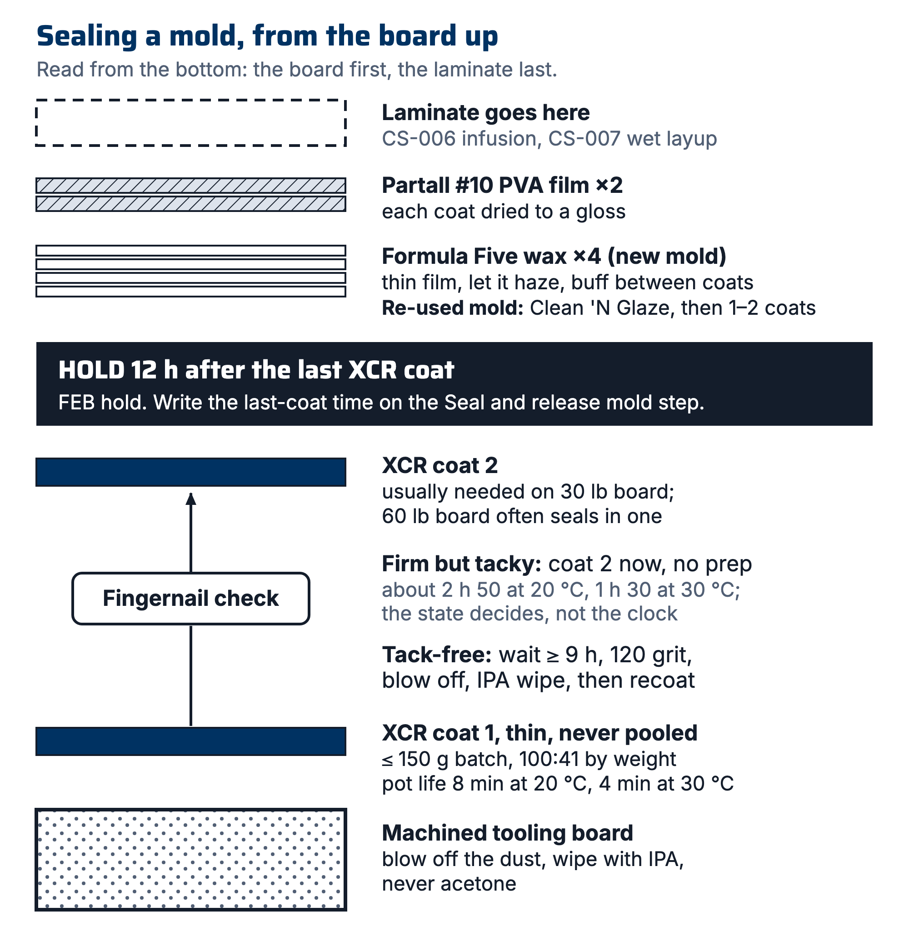
Figure 1. Sealing a mold from the board up: XCR coats with the fingernail check between them (firm but tacky: coat again with no prep), the 12 h FEB hold after the last coat, then wax and PVA, with the laminate last.

6. Safety
Per R2 (XCR SDS §2): the resin and the hardener both cause allergic skin reactions (H317) and serious eye damage (H318). The hardener is corrosive and causes severe skin burns (H314). The resin is suspected of causing genetic defects (H341). Neither part is classified as a respiratory sensitizer (no H334), though the resin SDS §11.1 says it may be a respiratory tract sensitiser; the respirator rule below is for vapor. Repeated careless exposure can make you permanently allergic to epoxies, which ends your composites career.
- Past reaction: anyone who has had a skin reaction to epoxy shall not mix or brush XCR, and tells a lead (R2 §7.1). There is other work on a sealing night.
- Gloves: nitrile (chemical-resistant per EN ISO 374-1), always, both components and mixed resin. Change gloves if resin gets on them.
- Ventilation: use only with adequate ventilation (R2 §8.2). Seal molds in the open shop area or with doors open, not in a closed side room.
- Respirator: for prolonged brushing on large molds (undertray-scale) or poorly ventilated conditions, wear the team respirator with A-type (brown, EN 14387 A1) organic-vapor cartridges; dust filters alone do nothing against epoxy vapors.
- Eyes: safety glasses with side shields whenever XCR resin or hardener is open; prescription glasses are not eye protection. You should wear safety goggles with side protection (EN 166) when mixing or brushing XCR (R2 §8.2); goggles are on the purchase list.
- Skin: wash any skin contact immediately with soap and water (not solvent). Contaminated clothing stays at the shop (R2 P272).
- Exotherm: mixed XCR left in the pot self-accelerates (R1). Small batches, transfer to the surface promptly; if a cup gets hot/smokes, set it outside on concrete and let it finish; do not bin it hot (see CS-008).
- PVA/wax (R3–R5): low hazard; gloves and ventilation suffice.

7. Procedure

7.1 Clean after machining
- Blow all dust off the mold with compressed air, including pockets and scribe lines. [held for Simon: vacuum instead, REGISTER R-004-15]
- Wipe the entire surface with IPA-dampened microfiber cloth; repeat with a clean face until the cloth comes away clean.
⚠ CAUTION: Never use acetone on tooling board (it attacks the board) and never use fibrous cloths/paper shop towels (strings pull out and embed in the surface): both are SN4-documented failure modes (R7).
- From this point, gloves only; skin oils contaminate the surface.

7.2 Inspect and touch up
- Check every scribe line and datum is crisp and visible. Photograph the dry mold; this is the reference for "did sealing obscure anything".
- Fill any machining defects/gouges per CS-003 before sealing.
[ PHOTO: machined, cleaned mold with scribe lines visible, before sealing ]

7.3 Sealing with XCR: batch size, coats, overcoat window
- Confirm workspace is 15–30 °C and can stay ≥20 °C through the cure (R1). Both jugs, resin and hardener, are inside 15–30 °C before you mix; on a cold night, bring them in from storage first. Avoid a humid room (R1). Do not seal outdoors on cold evenings; R1 rates XCR for 15–30 °C only.
- Batch size: mix 150 g or less at a time. Pot life at that size is only 8 minutes at 20 °C (4 at 30 °C), and a bigger batch is shorter-lived and hotter. A 150 g batch covers roughly a medium mold section per coat; mix again rather than mixing big. Record each batch mass on the WO.
- Weigh XCR at 100:41 resin:hardener by weight (R1). Mix thoroughly ≥2 min, scraping walls and base; then double-pot: transfer to a second cup and remix with a fresh stick (R1). Unmixed streaks from cup walls are the classic soft-spot cause.
- Brush a thin, even first coat over the whole working surface plus flanges, working quickly (see step 2's clock). Work resin out of corners and fillets: pooling in crevices is the Duratec failure mode we are not repeating; a thin coat that needs a second pass beats a thick coat that pools.
How many coats: 30 lb board usually needs a second coat; 60 lb board often seals in one. Plan two coats on 45 lb board until the team has a record of it sealing in one (team rule). A mold cut from a range of grades seals like its softest board, so you should plan two coats if any of it is 30 or 45 lb (the mold's "Board density, min" and "Board density, max" fields show the range).
- Watch scribe lines as you coat: they must remain visible. If a line floods, drag the brush along it to re-open the meniscus before the resin gels.
- Second coat timing: overcoat when the first coat is firm but tacky: firm, soft enough to indent with a fingernail, a slight tack on the surface. At 20 °C that is usually about 2 h 50 after the coat went on (1 h 30 at 30 °C), but the clock is an estimate; check with a fingernail, and the state decides (R1). A coat applied in that state bonds chemically with no prep (R1).
If the first coat has gone tack-free (coming back another day always means tack-free), recoat this way (R1):
- Wait at least 9 h from application.
- Key the surface with 120 grit.
- Blow off the dust.
- Wipe with IPA.
- Recoat.
- Wait out the FEB hold of 12 h after the last coat before the release system (§7.4) goes on (team hold, CS-008 §5). The datasheet gives initial cure as 8 h 30 at 20 °C, handleable at about 9 h (R1); the 12 h is the team's margin over it. The app does not lock this hold, so write the last-coat time in the note on the work order's "Seal and release mold" step. Only if a run/nib formed: locally denib with ≥800 grit (team value), then re-wipe with IPA.
- Keep water away from the sealed surface for 24 h (R1).
⚠ CAUTION: Mix only a ≤150 g batch and get it out of the cup fast. At 8 minutes of pot life, a phone call is the difference between a coat and a smoking cup.
[ PHOTO: first XCR coat going on, brush working resin out of a fillet ]

7.4 Release: wax coats, then PVA
- On a fresh sealed mold, once the 12 h hold in §7.3 step 7 has passed: apply Formula Five wax per R4: thin film, let haze, buff with clean microfiber. 4 coats minimum on a new mold (team count; R4 asks for at least three), buffing between coats.
- Wait at least 1 h after the last wax coat before the PVA goes on, so the wax solvents out-gas (R4; R3).
- Apply Partall #10 PVA film per R3: thin, even coats; let each dry fully (it dries to a visible glossy film), about 15 to 45 min a coat (R3). 2 coats (team count; R3 gives a mist coat then flow coats on a new mold).
- On a re-used sealed mold: clean with Clean 'N Glaze (R5), then 1–2 wax coats, the 1 h wait and PVA as above.
- On the Molds tab, open the mold and set Sealing system = XCR, Sealed on = the date of the last XCR coat, Sealed by = you (pick yourself from the list), and Stage = Sealed. Write the XCR batch masses, coat count, coat times, and the wax and PVA coat counts in the note on the work order's "Seal and release mold" step.
[ PHOTO: PVA film drying: even gloss, no fisheyes ]

7.5 Identify
The last step, after every wet operation is finished. Doing it earlier does not work: a label applied before the XCR either gets brushed over, becoming a permanent bump in the seal coat, or gets peeled off and leaves adhesive the XCR will not wet out.
- Choose a patch on the back face, inboard of the 40 mm keep-out at every edge (CS-001 §6 rule 2). Never the working surface. The keep-out is there because tacky tape is 12.7 mm wide, and a label edge under the seal is a leak channel you will not find at 27 inHg (CS-001 §6).
- Scuff the patch to 220 grit and wipe with IPA. Tooling board is porous; without this the adhesive has nothing to key into and the label curls off within a month.
- Print the mold's label from the app and apply it. Check the printed parts-pulled count, seal date and sealed-by name match what you just recorded.
- Confirm the engraved ID from CS-005 is still legible. If machining or rework removed it, re-engrave or stamp before the mold leaves.
- Set the mold's Stage to Ready for layup. It is now cleared for CS-006 (infusion) or CS-007 (wet layup).
⚠ CAUTION: On a re-seal, the old label comes off with the strip and a new one is printed carrying the new seal date and the incremented parts-pulled count. A label reading SEALED 2025-11-02 · J LEE · USES 09 is telling you something important, and reprinting is how it stays true.

8. Quality checks / acceptance criteria
Check | Target | Method | Record where
Scribe/datum visibility after sealing | All lines identifiable vs 7.2 photo | Visual compare | WO qualityChecks + photo
No pooling | No glossy pools in fillets/corners | Visual, raking light | WO qualityChecks
Cure | Fingernail does not mark surface, checked at or after the 12 h hold (CS-008 §5) and before the release system goes on | Press test on flange (not part surface) | WO step
Release film | Continuous PVA gloss, no fisheyes/dry patches | Visual | WO qualityChecks
First-article release (new mold or new product batch) | Test patch releases by hand | Small cured resin dab on flange, pop off | WO notes

9. Records
The mold record carries Sealing system, Sealed on, Sealed by and Stage (§7.4 step 5, §7.5 step 5). The note on the work order's "Seal and release mold" step carries the XCR batch masses and count, coat count and coat times (in or out of the overcoat time), the last-coat time that starts the 12 h hold, and the wax and PVA coat counts. The work order also holds the 7.2 and 7.4 photos and the quality-check table. This is what makes "why did part X stick?" answerable in minutes.

Appendix: the Duratec history (why XCR)
Duratec (SN4–early SN5): expensive, hid etch marks by pooling, mandatory high-grit sand-back on soft board, frequent sand-through → re-coat cycles. The Oct 2025 Mold Sealer Alternatives study recommended S120/water-based sealers as a cheap replacement; by Feb 2026 the team instead ordered XCR with the Easy Composites basket, first parts sealed with it in April 2026 ("Core and XCR has arrived, good to seal", #composites, 2026-04-28), and the undertray was coated with XCR in May. Root-cause note (PP-01): the durable fix wasn't the product swap itself but owning the selection decision in a standard, this document. If XCR is ever replaced, revise this standard (CS-000 §7.2), don't just switch cans.

